**Remarks**

Signature

**Assignment**

|  |  |
| --- | --- |
| Subject Name | **:** Programming in Java |
| Subject Code | **:** 66651 |
| Expt. / Job No | **:** 02 |
| Name of the Expt. / Job | **:** Java programs using inheritance and polymorphism. |
| Date of the Expt. / Job | **:** 25-07-2022 |
| Date of the Sub. / Job | **:** 27-07-2022 |

|  |  |  |  |
| --- | --- | --- | --- |
| **Submitted By:** | | **Submitted To:** | |
| Name | : Md. Jahid Hossain | Name | : Meherun Akhi |
| Department | : Computer | Lecturer | **:** Computer |
| Board Roll | : 434575 |  |  |
| Semester | : 5th |  |  |
| Session | : 2019-2020 |  |  |

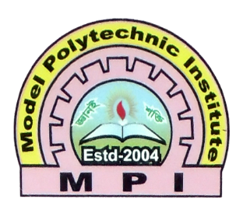

**MODEL POLYTECHNIC INSTITUTE, JASHORE**